E-PROJECT: PET BOTTLE

USER GUIDE

Supervisor | Sir Hamza Shamim
Batch | 2507B
Serial No. | Enrollment No. | Student Name
1 | Student1676866 | Syed Azmeer Hussaini
2 | Student1676531 | Rehman
3 | Student | Mehboob

E-PROJECT: PET BOTTLE

The PET Bottle Website is a specialized digital platform designed to showcase high-quality plastic and glass packaging solutions. The project aims to provide a professional catalog for various industries—such as beverage, food, and wellness—offering a seamless browsing experience for durable containers

Navigation Bar
The navigation bar serves as the central hub of the website, located at the top of every page to ensure consistent accessibility. It features:
- Interactive Links: Home, Bottles, Jars, About Us, Contact Us, and Feedback.
- Hover Effects: Menu items highlight and feature a bottom border in gold/yellow to guide the user.
- Sticky Design: It remains fixed during scroll to provide easy access to different sections.

E-PROJECT: PET BOTTLE

Logo
The website logo acts as a graphic symbol of manufacturing quality and brand authenticity.

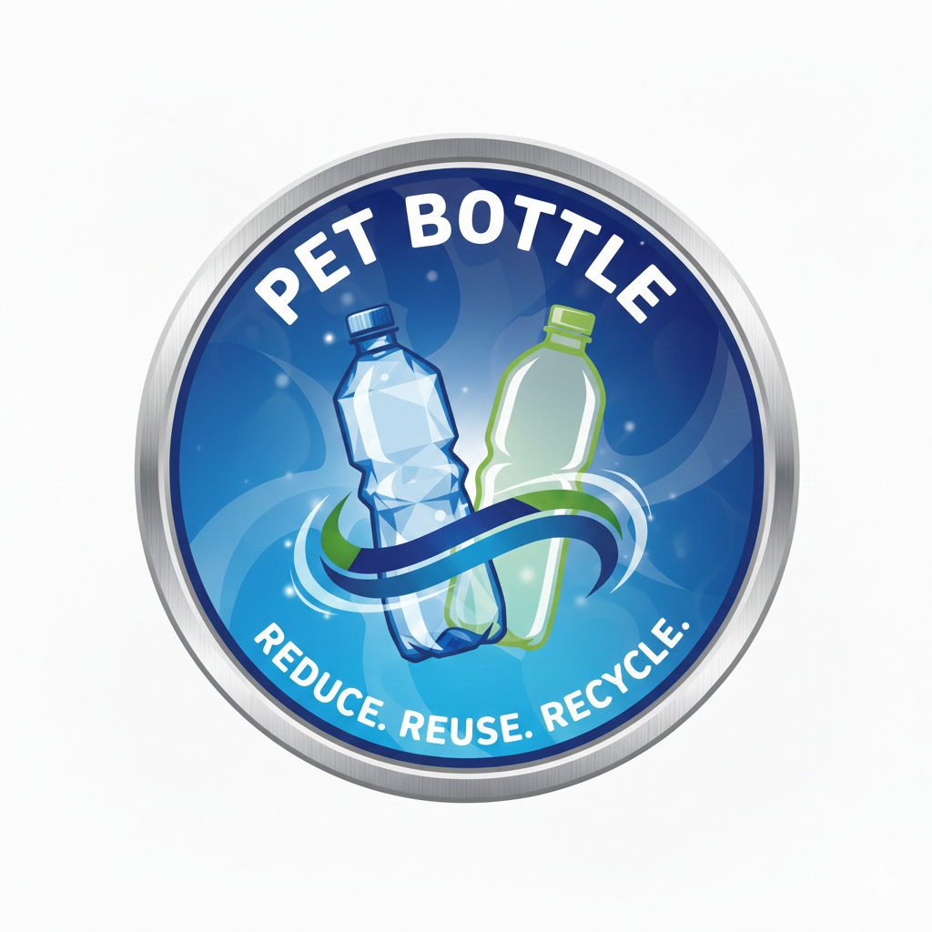
E-PROJECT: PET BOTTLE

Home Page
A professional industrial interface featuring high-definition product visuals, categorized sections, and a clean corporate aesthetic.

Hero Section
The Hero Section of the PET Bottle website serves as the primary visual attraction and the defining identity for the digital storefront.
• Primary Visuals: The section features a high-definition brand logo and a professional background using a linear-gradient from #0a3d62 to #1e3799.
• Typography: It utilizes bold, centered headings with the title "PET Bottle Manufacturing Website" paired with a modern sub-text: "High Quality Plastic Bottles & Jars".
• Modern Layout: The layout is designed to be the central visual hub, focusing on a clean, premium aesthetic that instantly engages the user.
• Branding: The official logo is prominently displayed as a graphic symbol of authenticity and luxury manufacturing.
• Navigation Integration: The hero area is positioned immediately below the navigation bar, which features interactive links that highlight in gold/yellow to guide the user.


E-PROJECT: PET BOTTLE

Best Selling Collections
The Product Section displays the most popular manufacturing catalogs, organized by material and utility.
- Product Focused: Dedicated sections for "Best Selling" glass bottles and steel bottles to maintain organized inventory viewing.
- Visual Navigation: Each product is represented by a high-quality signature image, such as the Glass Water Bottle or Steel Speed Bottle.
- Dynamic Hover Effects: Product cards scale up (transform: scale 1.05) when hovered to provide a responsive user experience.
- Direct Routing: Clicking "View All" redirects the user to the comprehensive product catalog.

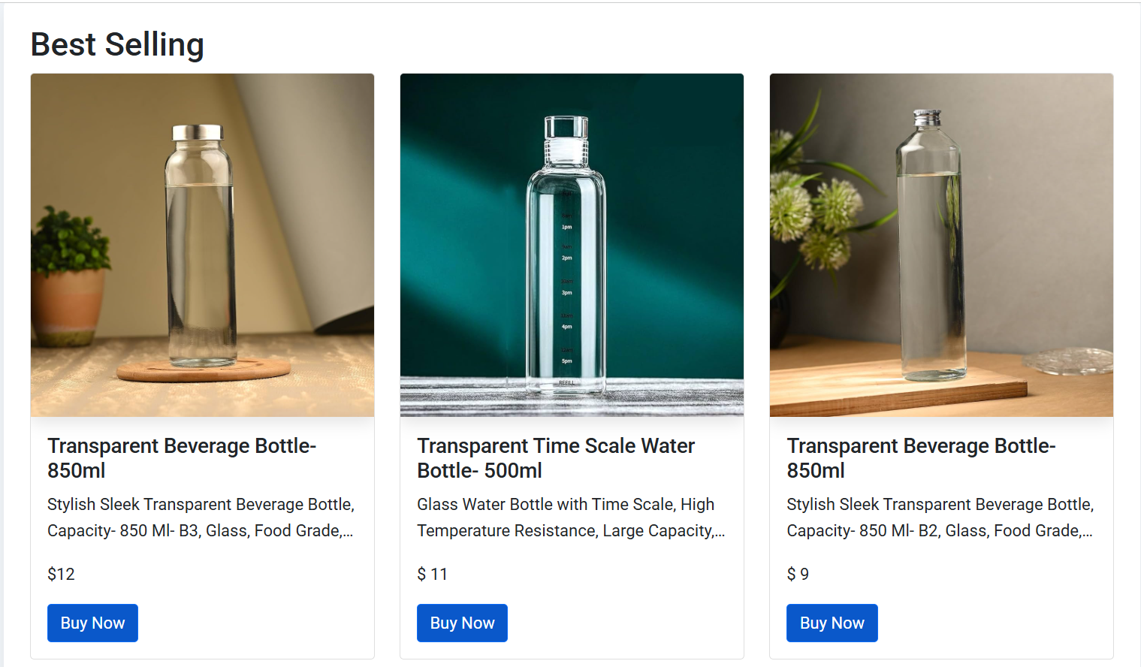
E-PROJECT: PET BOTTLE

Product Catalog
On the dedicated product page, users can browse specific manufacturing items categorized by material.
- Material Sorting: Users can view collections including Transparent Glass, Stainless Steel, and Temperature-controlled flasks.
- Product Cards: Each item displays a high-quality image, a specific title (e.g., "Transparent Beverage Bottle- 850ml"), and a detailed technical description.
- Clear Pricing: The price for each item (e.g., $12 or $8) is clearly displayed beneath the description.
- Acquire Button: A prominent blue "Add to Cart" button allows for immediate selection.
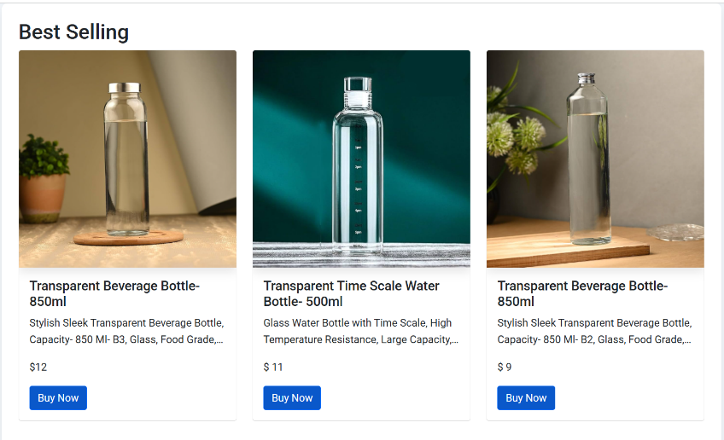
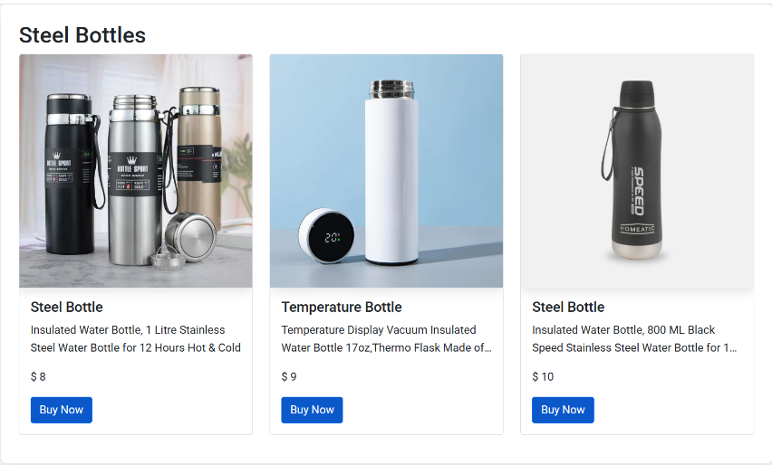
E-PROJECT: PET BOTTLE

PRODUCT DETAIL PAGE
• Primary Product Display: Features a high-definition image of the Transparent Time Scale Water Bottle (500ml) with clear measurement markings.
• Interactive Navigation: Includes directional arrows on the image to allow users to view the bottle from different angles.
• Technical Specifications: Highlights key features such as High Temperature Resistance, large capacity, and suitability for water or juice.
• Pricing and Rating: Displays a prominent price of $11 alongside a five-star customer rating system for quality assurance.
• Purchase Controls: Includes a Quantity Selector with plus/minus buttons and a blue "Order Place" button for direct checkout.
• Discovery Section: A "Best Selling" area at the bottom encourages users to browse additional related products.

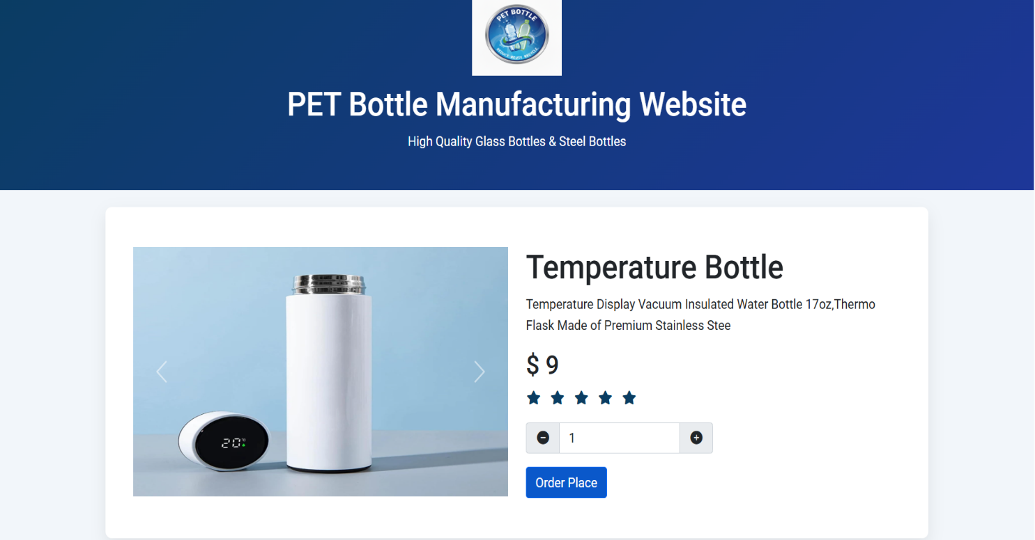

E-PROJECT: PET BOTTLE

About - Us
Users can learn about the manufacturing standards and the specific design features of products—like the Stanley Quencher's vacuum insulation—by clicking the About Us section or the "View More" button.
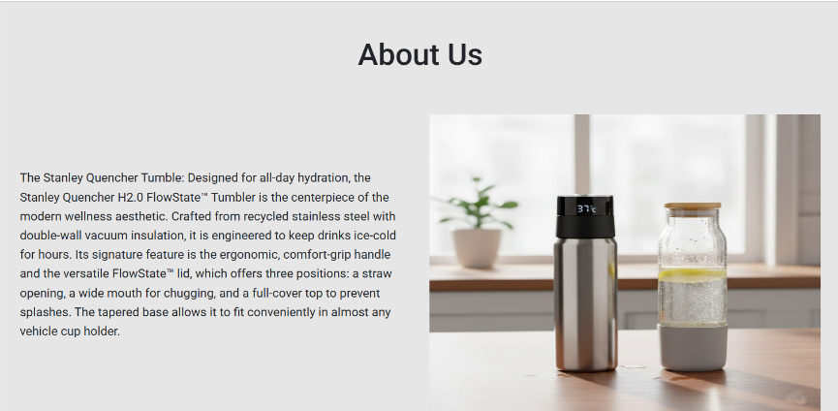

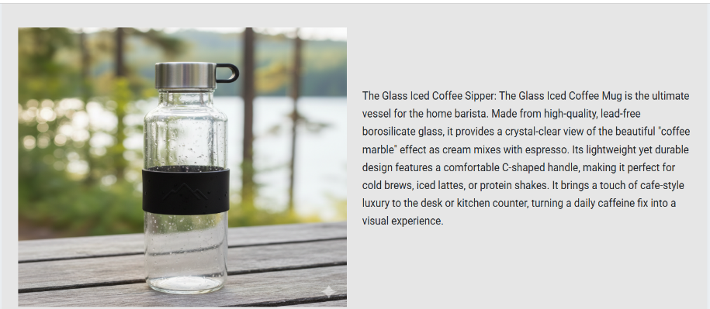

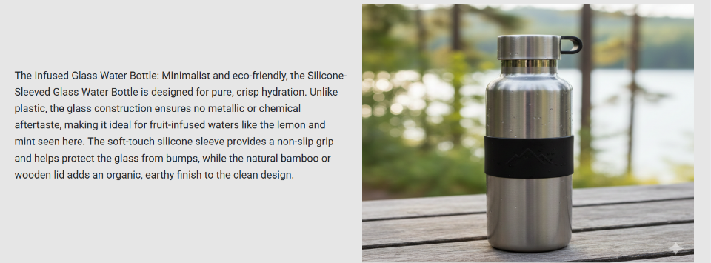
E-PROJECT: PET BOTTLE

Contact - Us
Clients can get in touch to discuss bulk requirements or design specifications by using the contact details or filling out the integrated communication form.

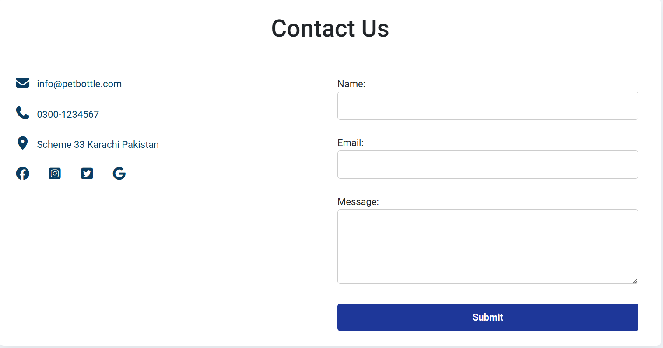
E-PROJECT: PET BOTTLE

Footer
- Location: Situated at the bottom of the page.
- Content: Displays the copyright information "© 2025 PET Bottle Project" to establish professional ownership.

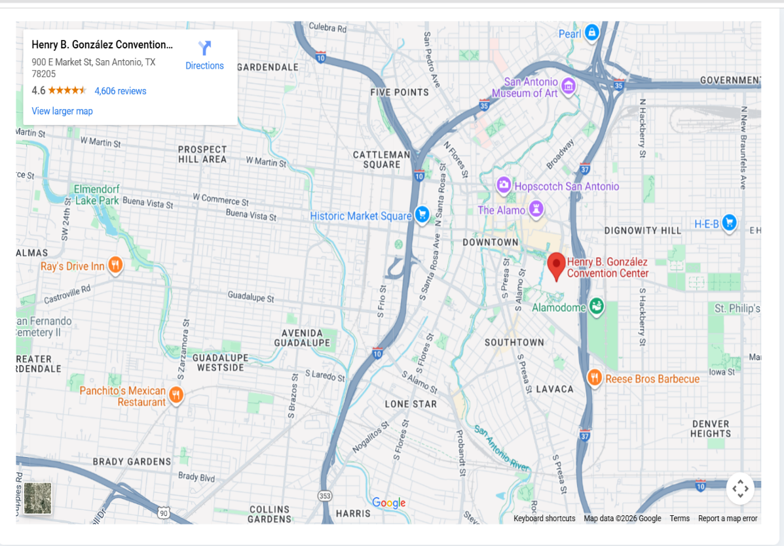

THANKS FOR READING OUR DOCUMENTATION

